1. All the Exercises for Gradle are similar to Maven
2. For Maven POM.XML is the configuration file and for Gradle build.gradle is the build configuration file
3. Complete the exercises for Groovy and Kotlin as well

Steps are similar (select Kotlin while creating project)

1. Maven to Gradle Migration

**Please find the screen shot below**

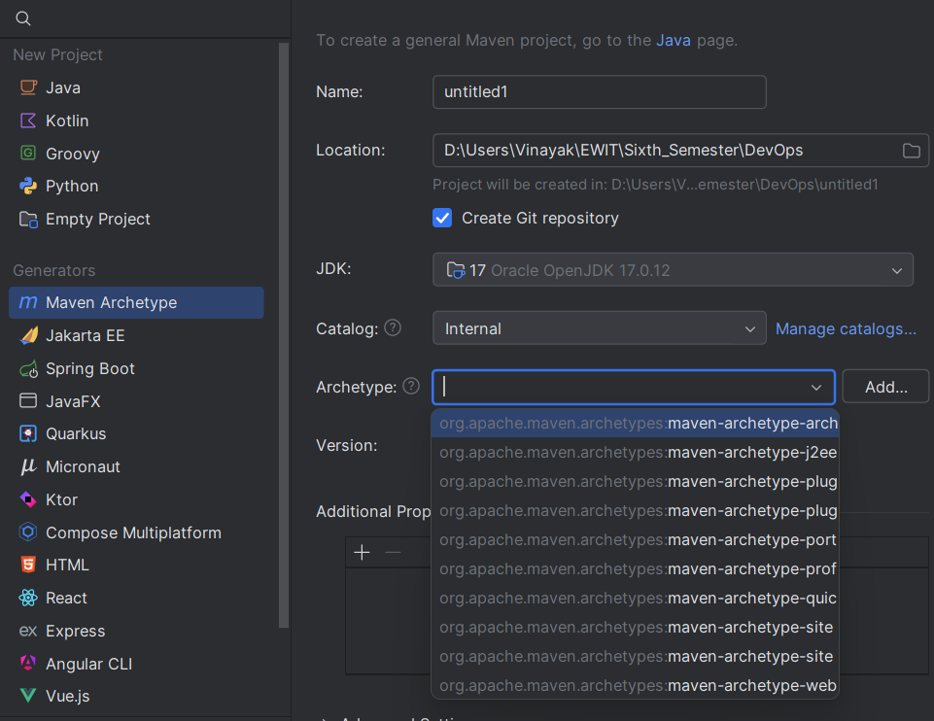

**Select maven-archetype-quickstart**

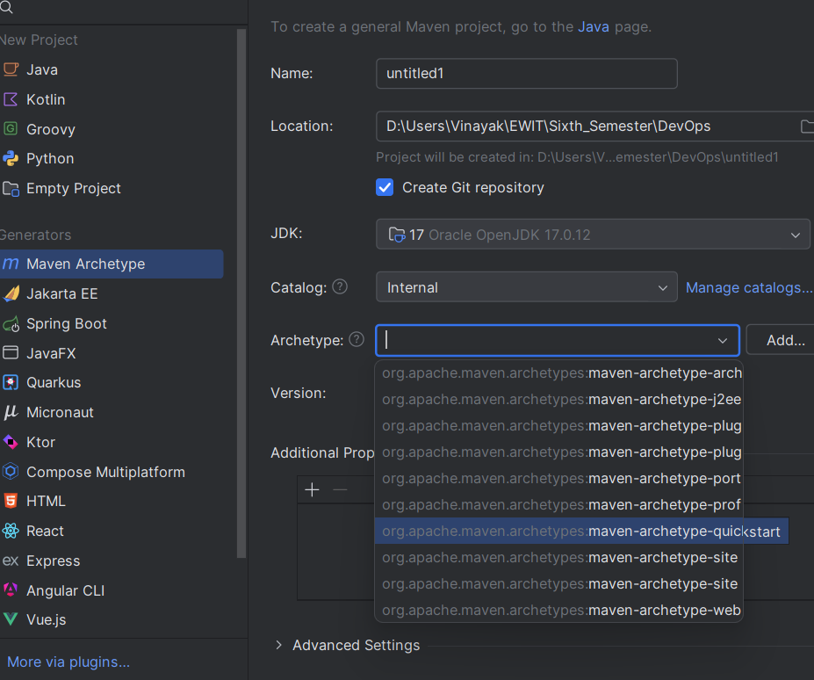

**Project Structure**

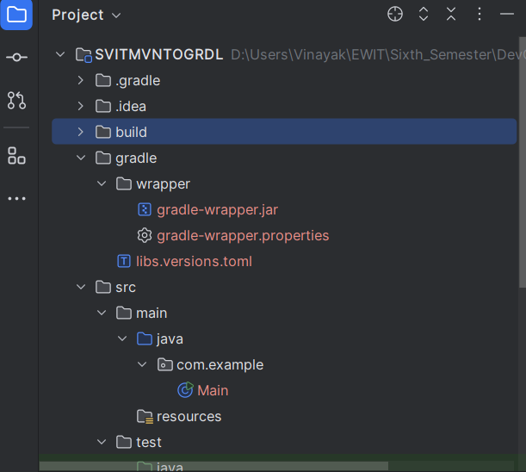

**Please note that you have build.gradle and pom.xml are there in the project structure**

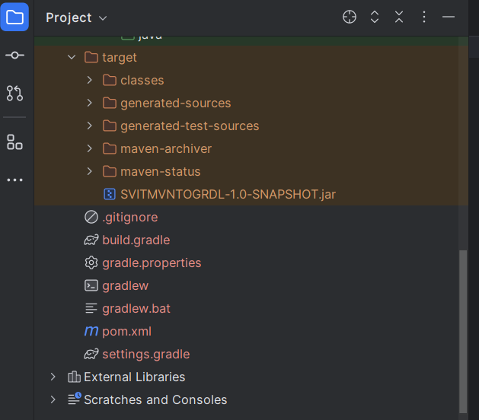

**POM.XML**

<?xml version="1.0" encoding="UTF-8"?>  
<project xmlns="http://maven.apache.org/POM/4.0.0"  
 xmlns:xsi="http://www.w3.org/2001/XMLSchema-instance"  
 xsi:schemaLocation="http://maven.apache.org/POM/4.0.0 http://maven.apache.org/xsd/maven-4.0.0.xsd">  
 <modelVersion>4.0.0</modelVersion>  
  
 <groupId>com.example</groupId>  
 <artifactId>SVITMVNTOGRDL</artifactId>  
 <version>1.0-SNAPSHOT</version>  
  
 <properties>  
 <maven.compiler.source>17</maven.compiler.source>  
 <maven.compiler.target>17</maven.compiler.target>  
 <project.build.sourceEncoding>UTF-8</project.build.sourceEncoding>  
 </properties>  
  
 <build>  
 <plugins>  
 <plugin>  
 <groupId>org.apache.maven.plugins</groupId>  
 <artifactId>maven-compiler-plugin</artifactId>  
 <version>3.8.1</version>  
 <configuration>  
 <source>1.8</source> <!-- Java version -->  
 <target>1.8</target>  
 </configuration>  
 </plugin>  
  
 <!-- JAR Plugin -->  
 <plugin>  
 <groupId>org.apache.maven.plugins</groupId>  
 <artifactId>maven-jar-plugin</artifactId>  
 <version>3.2.0</version>  
 <configuration>  
 <archive>  
 <manifest>  
 <addClasspath>true</addClasspath>  
 <mainClass>com.example.Main</mainClass> <!-- Replace with your main class -->  
 </manifest>  
 </archive>  
 </configuration>  
 </plugin>  
 </plugins>  
 </build>  
  
</project>

**BUILD.GRADLE**

plugins **{** id 'java'  
**}**group = 'com.example'  
version = '1.0-SNAPSHOT'  
  
repositories **{** mavenCentral()  
**}**dependencies **{** testImplementation 'junit:junit:4.13.2'  
**}**jar **{** manifest **{** attributes(  
 'Main-Class': 'com.example.Main'  
 )  
 **}  
}**

**Main.java**

package com.example;  
  
public class Main {  
 public static void main(String[] args) {  
 System.*out*.println("Hello, World!");  
 }  
}